Project Planning Phase
Project Planning Template (Product Backlog, Sprint Planning, Stories, Story points)

Date | 20 february 2026
Team ID | LTVIP2026TMIDS72915
Project Name | Measuring the pulse of prosperity: - An index of economic freedom analysis
Maximum Marks | 5 Marks

Product Backlog, Sprint Schedule, and Estimation (4 Marks)
Use the below template to create product backlog and sprint schedule

Sprint | Functional Requirement  (Epic) | User Story Number | User Story / Task | Story Points | Priority | Team Members
Sprint-1 | Data Collection | USN-1 | As a user, I want to collect economic data from the Index of Economic Freedom API. | 3 | High | Kavya Sai
Sprint-1 | Data Preprocessing | USN-2 | As a user, I want to clean and normalize the dataset for analysis. | 3 | High | Manasa
Sprint-2 | Data Analysis | USN-3 | As a user, I want to analyse correlation between freedom index and GDP. | 4 | Medium | Madhusudhan Rao
Sprint-2 | Prediction Model | USN-4 | As a user, I want to predict GDP using economic indicators. | 5 | Medium | Kaveri
Sprint-3 | Dashboard | USN-5 | As a user, I want to see the data in an interactive dashboard (Stream lit). | 3 | High | Kavya Sai
Sprint-3 | Filtering | USN-6 | As a user, I want to filter dashboard data by country and year. | 2 | Medium | Manasa
Sprint-4 | Report Generation | USN-7 | As a user, I want to download summary reports of findings as PDFs. | 2 | Low | Madhusudhan Rao

Project Tracker, Velocity & Burndown Chart: (4 Marks)

Sprint | Total Story Points | Duration | Sprint Start Date | Sprint End Date (Planned) | Story Points Completed (as on Planned End Date)
Sprint-1 | 6 | 6 Days | 01 December 2026 | 06 December 2026 | 06
Sprint-2 | 9 | 6 Days | 07 December 2026 | 12 December 2026 | 12
Sprint-3 | 5 | 6 Days | 13 December 2026 | 18 December 2026 | 18
Sprint-4 | 2 | 6 Days | 19 Feburary 2026 | 20 Feburary 2026 | 24

Velocity:
Imagine we have a 10-day sprint duration, and the velocity of the team is 20 (points per sprint). Let’s calculate the team’s average velocity (AV) per
iteration unit (story points per day)
Average Velocity = 5.5 Story Points per Sprint

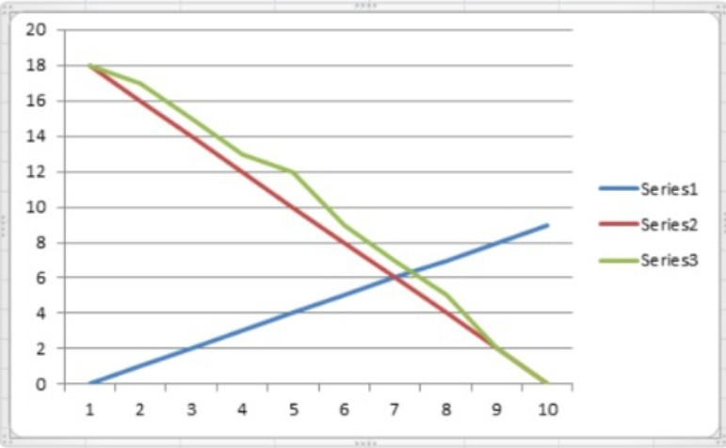

Burndown Chart:

A burn down chart is a graphical representation of work left to do versus time. It is often used in agile software development methodologies such as Scrum. However, burn down charts can be applied to any project containing measurable progress over time.

https://www.visual-paradigm.com/scrum/scrum-burndown-chart/ https://www.atlassian.com/agile/tutorials/burndown-charts

Reference:
https://www.atlassian.com/agile/project-management https://www.atlassian.com/agile/tutorials/how-to-do-scrum-with-jira-software https://www.atlassian.com/agile/tutorials/epics https://www.atlassian.com/agile/tutorials/sprints https://www.atlassian.com/agile/project-management/estimation https://www.atlassian.com/agile/tutorials/burndown-charts

